Landing Page:

Index.html is the landing page.

Large Screen:

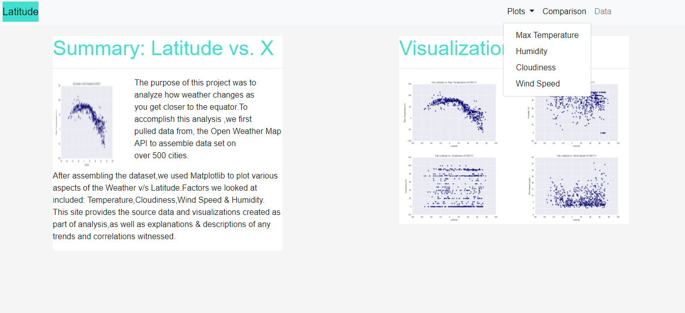

Small Screen: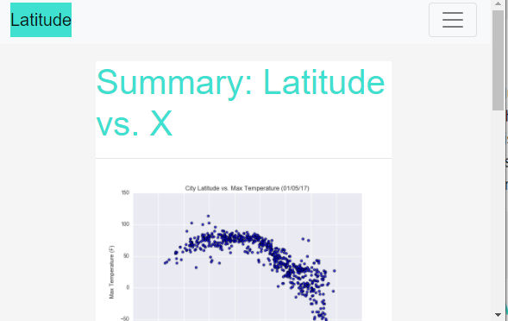

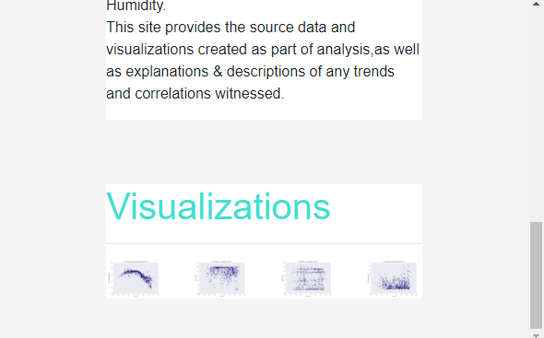

Visualizations Large Screen:

MaxTemp.html

Cloudiness.html

Humidity.html

WindSpeed.html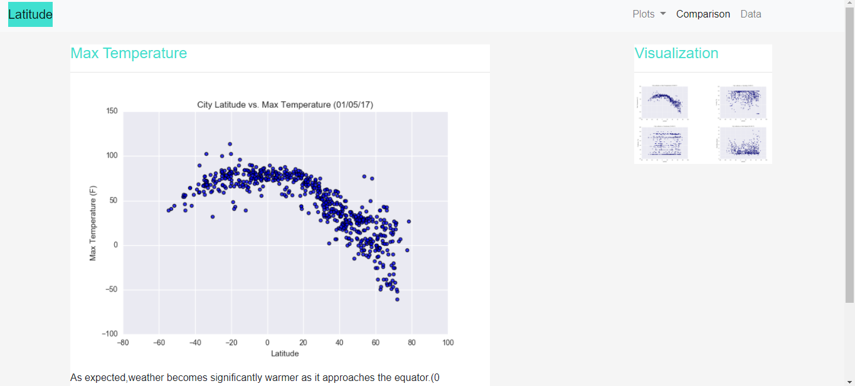

Visualizations Small Screen:

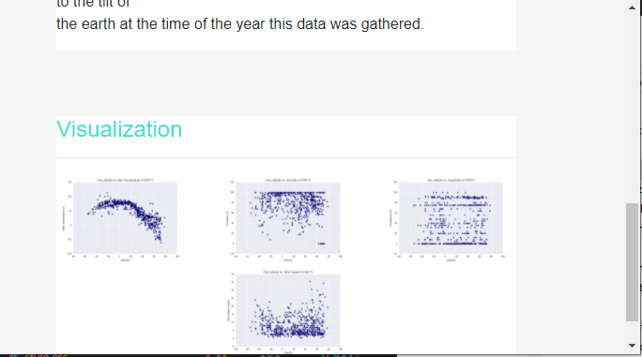

Data Page:

Data.html

Large Screen: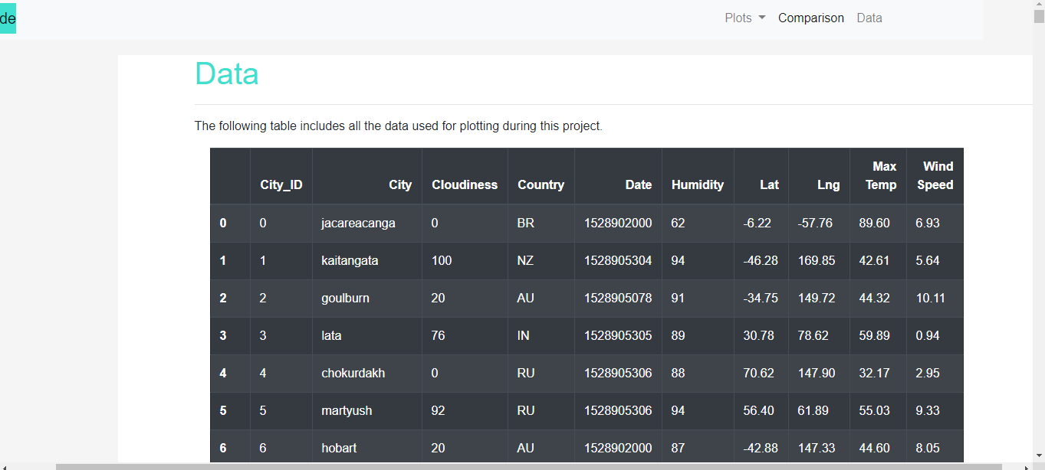

Small Screen:

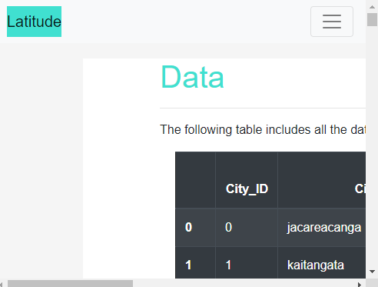

Comaprison Page:

Comparison.html

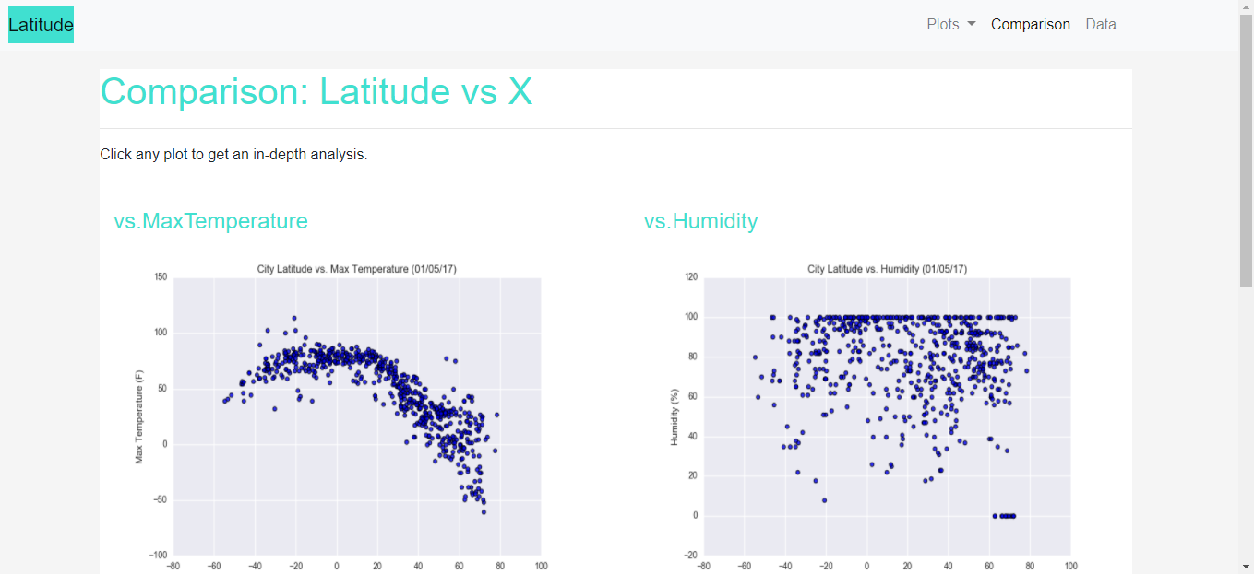

Small Screen:

